**JPL Editor Plugin**

**Features in Version 3.10.31:**

* Create Panther Projects
* Create Panther Libraries
* Import Panther Libraries
* Export Panther Libraries
* Create JPL files
* JPL syntax validated for correctness
* Converts binary screens, reports and menus to ASCII
* Search and Compare files
* Content assist after “->” , i.e. @widget(“screen1”)->title=”Login Screen”
* Content assist after “_”, i.e. “ sm_” or “ dm_”
* Hyperlinking – for smart switching between call and procs
* Source Code Control Support

**Software Requirements:**

1. Eclipse IDE (Kepler/Mars/Neon):

To install this plugin you must install Eclipse onto your system. You may download it from <http://www.eclipse.org/downloads/eclipse-packages/>

*Install Xtext software using Eclipse Marketplace

Go to Eclipse IDE → Help → Eclipse Marketplace, find “Xtext 2.9”

*If you are using Eclipse Kepler SR2 or Eclipse Mars IDE for Java and DSL then there is no need to install Xtext. If you don’t find Xtext 2.9 on Eclipse Market Place, download it (tmf-xtext-Update-2.9.2.zip) from GitHub and install it like below:

Eclipse IDE → Help → Install New Software

Note: Please do not use higher or lower versions of xtext 2.9.x.

**Installation Instructions:**

Follow the step-by-step instructions below to install Prolifics’ JPL-E Plugin.

**Install JPL Editor Plugin**

1. Download JPL Editor Plugin from GitHub

<https://github.com/Prolifics-Panther/JPLEPlugins/>

1. Go to the Help menu and select “Install New Software”.
2. Click on the Add button and choose Archive and browse to the zip folder i.e. JPL Editor Plugin. Click OK.
3. Unselect ‘Group items by category’ in the Install window and select the check box
4. ‘JPLEPlugin’. Click Next.
5. Choose the Panther Plugin and Press Next.
6. Then click on the “I accept the terms of the license …” radio button. Click Finish.
7. You may ignore the Security Warning., and click OK
8. If you encounter any errors, redo Step 2 but this time choose Help>Install New
9. Software and uncheck “Contact all update sites during install to find required software”.
10. Restart Eclipse. The installation of JPL Editor Plugin is now complete. The very first thing to do is to create a new Panther Project.

**Create a Panther Project**

1. Please make sure SMBASE is set in your environment. It must point to the location of your Panther installation,

I.e. SMBASE=C:\Prolifics\Panther 550 (Windows)

SMBASE=/usr/develop/prolifics/panther550 (Linux)

1. From the Eclipse menu, click File-> New->Other->Panther -> Create Panther Project.
2. Enter a project name. For example “CurrDev2016” then press Finish. See Fig1
3. If Eclipse asks if you want to add Xtext nature to your project, please click on the Yes button.

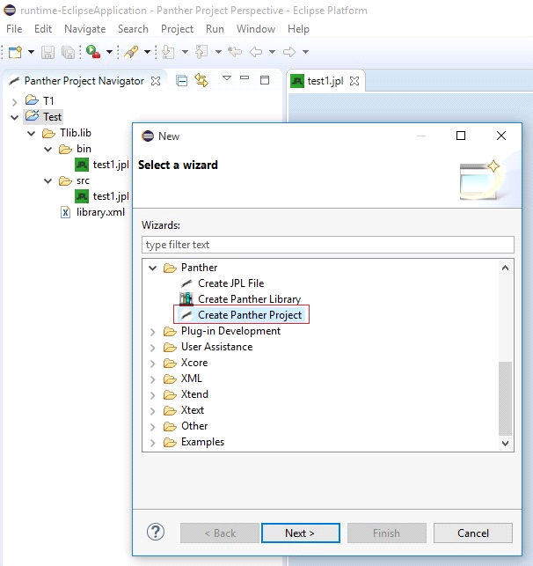

Fig1

**Import a Panther Library**

1. Your Panther library can contain screens, jpl, menus, reports, html, JavaScript, java files etc. Right click on your newly created Panther project. Select import from context menu.
2. Select Import Panther Library from the import wizard.
3. Click on Panther Library and then click on “Next”.
4. Browse to your Panther library e.g. test.lib.
5. Click on “Finish”. See Fig 4
6. All binary file are organized the <bin> folder and ASCII files are saved in the <src> folder.

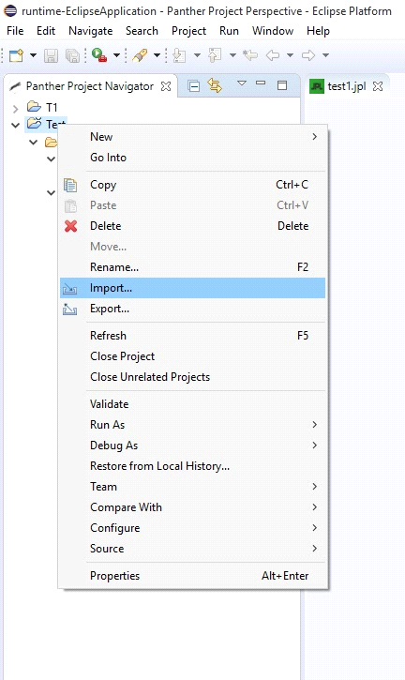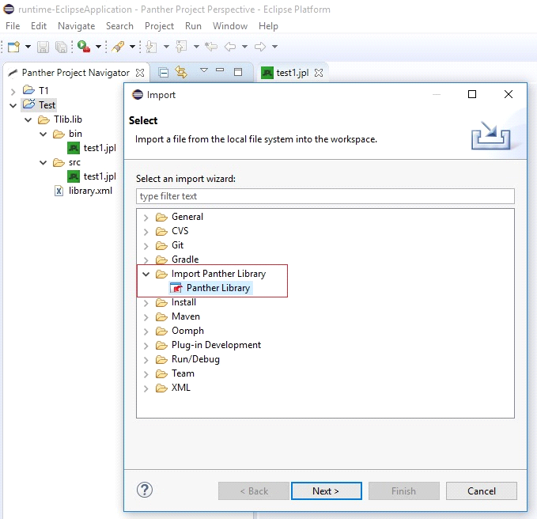

Fig2 Fig3

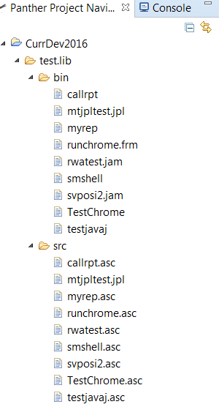 Fig4

**Create a Panther Library:**

1. Right click on <Project> -> New -> Other -> Panther -> Create Panther Library.
2. It contains <src> and <bin> directories and one library.xml. You can change the extension of generated binaries by adding jpl/bin in jpl-binary-filename-extension tag

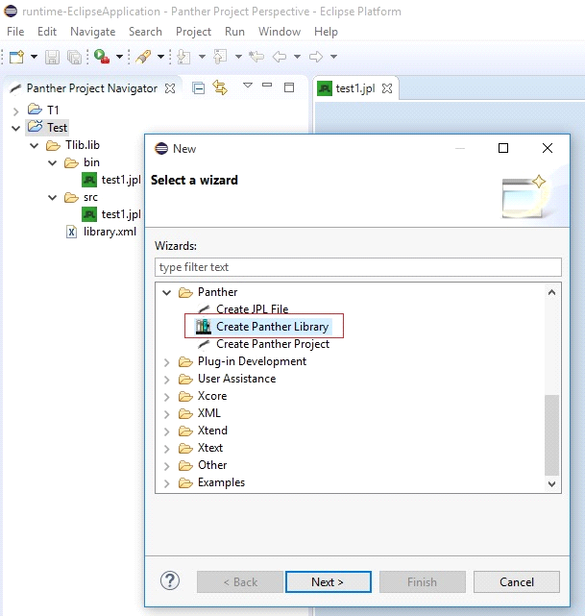

Fig5

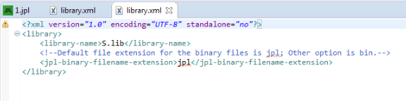

Fig6

**Create a New JPL File**

1. Right-mouse click on the <src> folder in which you would like to create the jpl file in, New -> Other -> Panther -> Create JPL File.
2. The filename MUST have a JPL extension, then press Finish.
3. When making an update in any ASCII file, once you save your changes the file is compiled to binary and stored in the <bin> folder.

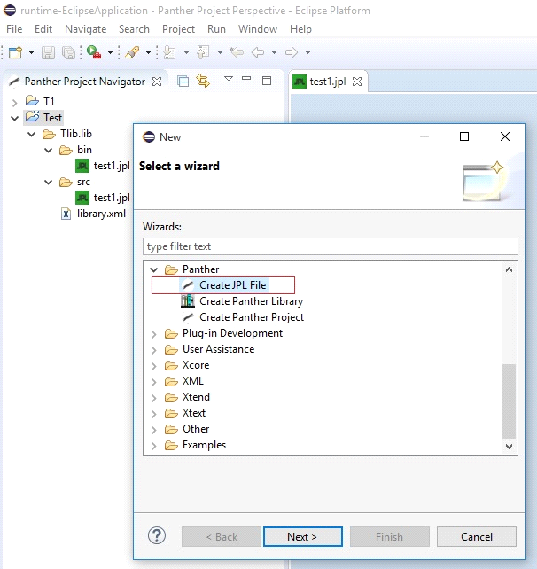

Fig7

**Export a Panther Library**

1. Right click on the Panther project library, Shazam.lib as shown in Fig8. Select export from the context menu.
2. Select Export Panther Library.
3. Then click on “Panther Library” and click on “Next”.
4. Browse the destination directory. This is where you will export your Panther library to.
5. Click on “Finish” button.

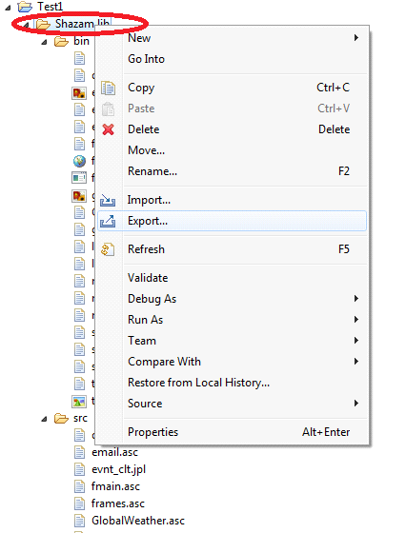

Fig8

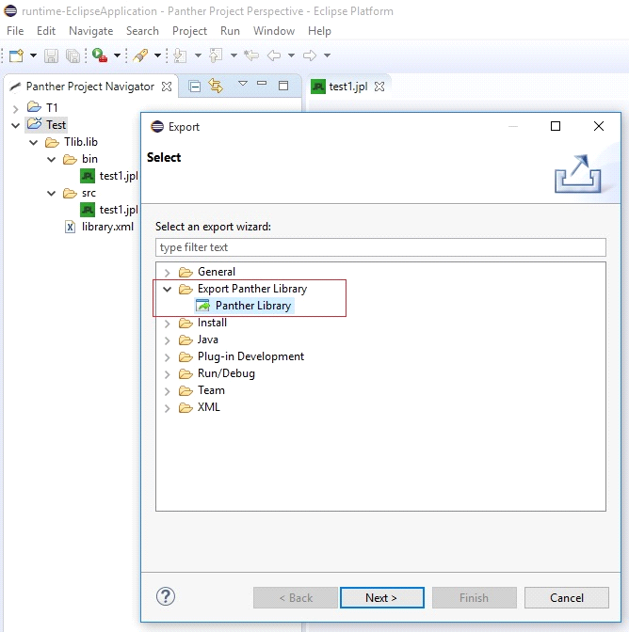

Fig9

**Uninstalling the Plugin**

If you need to remove an old JPL Plugin, uninstall it using Help->About Eclipse. Click on Installation Details and select the "JPL Plugin Editor", press uninstall. Confirm that you would like to uninstall it. Then Restart Eclipse.